# Open Movie

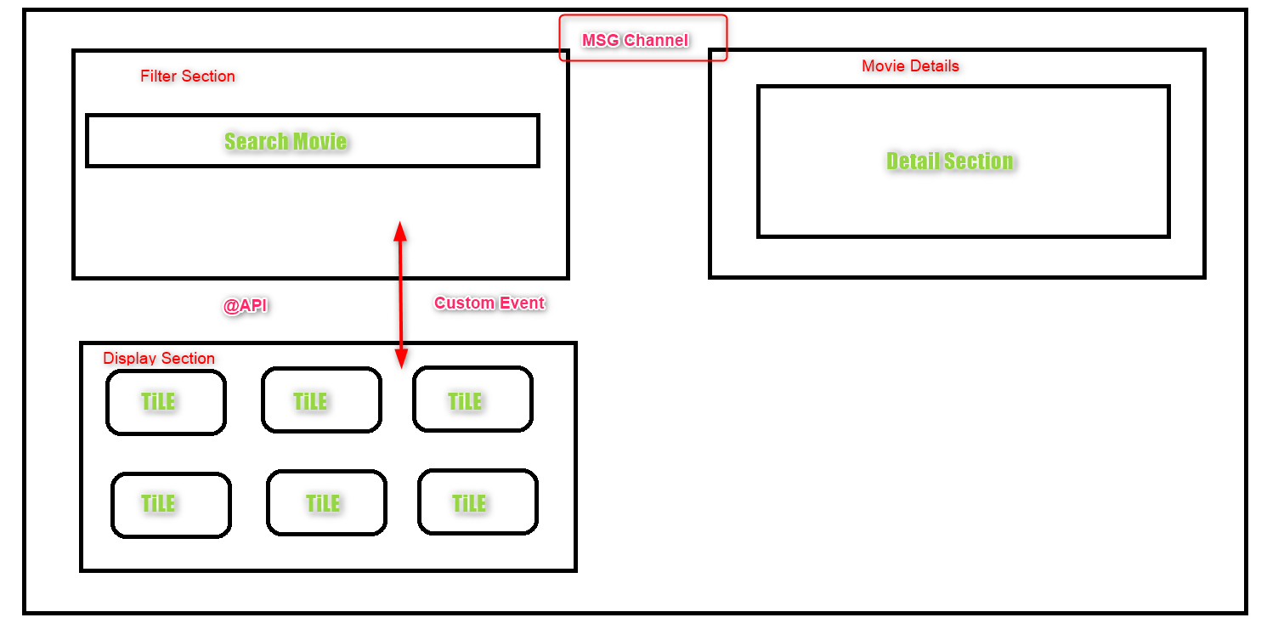

**Git Repo**: <https://github.com/MaheshGadad2024/MovieHubRepo.git>

**Public Api:**

**About Api:** The OMDb API (The Open Movie Database) is a RESTful web service to obtain movie information, all content and images on the site are contributed and maintained by our users.

**By Search Parameters We are using VALUES:**

| **Parameter** | **Required** | **Valid options** | **Default Value** | **Description** |
| --- | --- | --- | --- | --- |
| s | Yes |  | <empty> | Movie title to search for. |
| type | No | movie, series, episode | <empty> | Type of result to return. |
| y | No |  | <empty> | Year of release. |
| r | No | json, xml | json | The data type to return. |
| page New! | No | 1-100 | 1 | Page number to return. |
| callback | No |  | <empty> | JSONP callback name. |
| v | No |  | 1 | API version (reserved for future use). |

**By Search Parameters We are using as ID:**

## <http://www.omdbapi.com/?i=tt0094712>

## Learning From This Project:

### Tags and parameters Which helps:

Div, lightning-layout, lightning-layout-item, lightning-input, img, lightning-icon, lightning-combobox

### Styling Which mostly used:

Padding, border, border-radius, background-color, height, cursor, background-size, background-position, background-repeat, width, position

### Concepts which will help IN JS

**1. Destructuring.**

**2. Parent To Child and Child To Parent Communication**

**3.Component to Component Communication using LMS**

**4.how to use fetch method to call asynch process**

**5.Timout Functionality**

## Start:

### Configure Remote Site Setting:

Setup🡪 Remote Site Settings

https://m.media-amazon.com

<https://www.omdbapi.com>

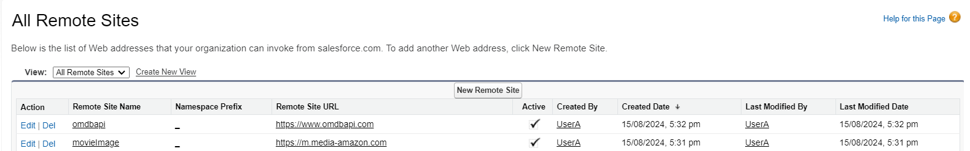

### Configure CSP Trusted URLs

Setup🡪 Trusted URLs

https://m.media-amazon.com

<https://www.omdbapi.com>

CSP Directives🡪Select All Check Box

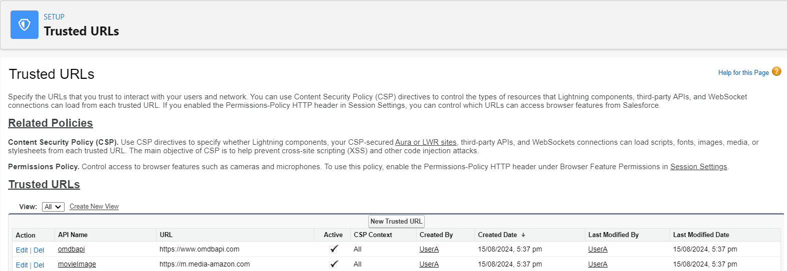

### Create App Page:

Lightning APP Builder—new –App page-labl (Movie Search)🡪Main Region and Right sideBar🡪done🡪Darg and drop Create Component 🡪save

Activate🡪Add this page to sales🡪save

## Enable A digital Experience:

* Setup a Digital Experience (one time step)
* **Create a site**s:Go To Setup🡪Digital Experience🡪Sites🡪new🡪select Build Your own(lwr)

🡪Name(MovieHub)🡪Url(Optional)🡪create

**There are Many types of sites:**

Marketing: Microsite (LWR)

Sales: Partner Central

Service: Help Center, Customer Account Portal, Customer Service

Build Your own(lwr)

Build Your Ownr(Aura)

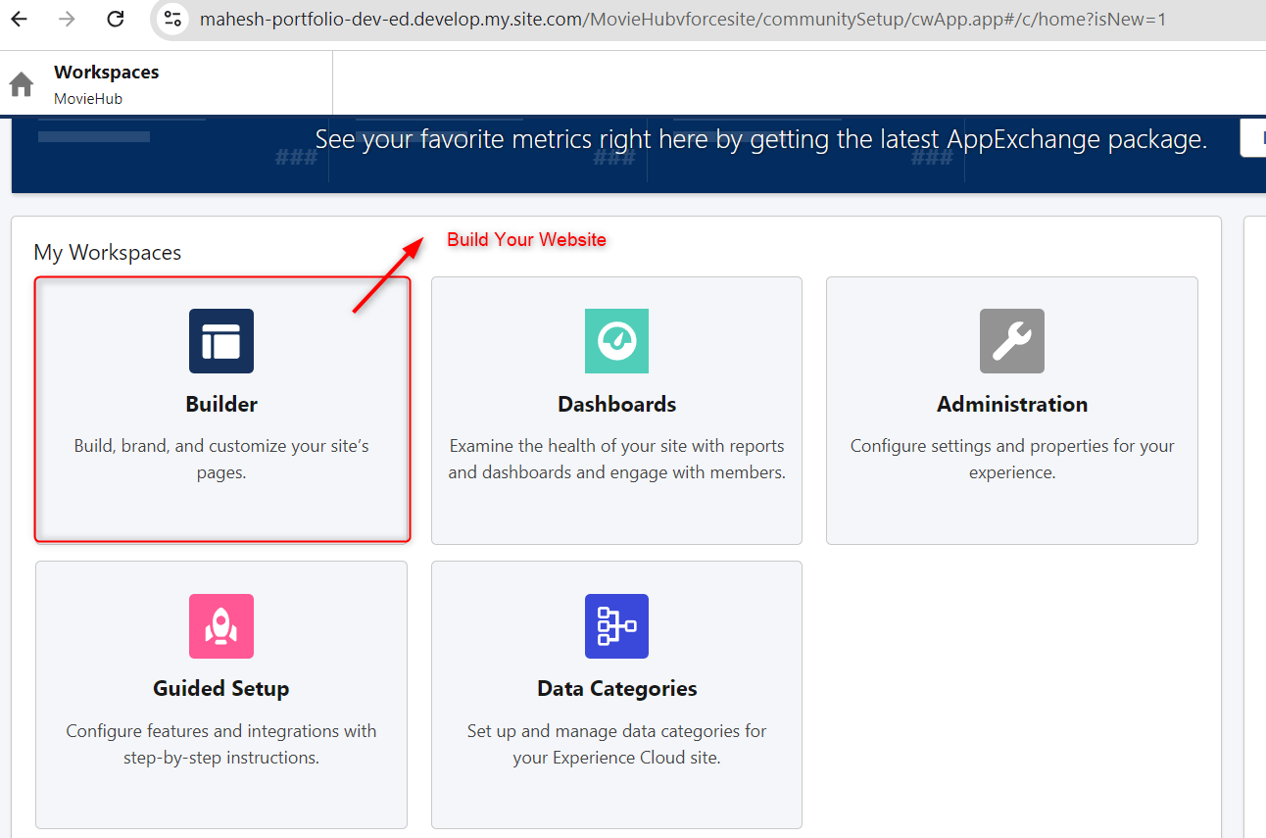

* Access to Guest user: Builder🡪Setting🡪General
* Relax CSP Setting: Builder🡪Setting🡪security and privacy
* Adjust layout and add Components (components are exposed to community)
* Activate site🡪Administration 🡪 <https://mahesh-portfolio-dev-ed.develop.my.site.com/MovieHub> -->Activate
* Publish Changes🡪Every LWC Changes, Site Needs to publish
* Validate OutPut